**SPINAL ORTHOSIS/ TLSO MEASURMENT FORM**

Diagnosis:

Prescription:

X-Ray Diagnosis:

Type of TLSO: BODY JACKET SCOLIOSIS BRACE CAD-CAM BRACE

Other:________________

BRACE DESIGNS

Axilla Extension:

Thoracic Pad:

Lumbar Pad:

Trochanter Extension:

Curve Type: _________________________________________________________________________________________________________________________________________________________________________________________________________________________________

ORTHOTIC OPTIONS

Straps: Lapel:

Abdominal Strap:

Gusset Material on window? Yes No

Cut out Location:

Opening: Anterior Posterior Bi Valve

Offset Opening: Left Right

Lordosis: 0 10 15 _____*

Additional Specification:______________________________________________________________________________________________________________________________________________________________________________________________________________________

MATERIAL

Material:

Thickness:

Colour / Transfer:

Lining: ___________________________ 3mm 6mm

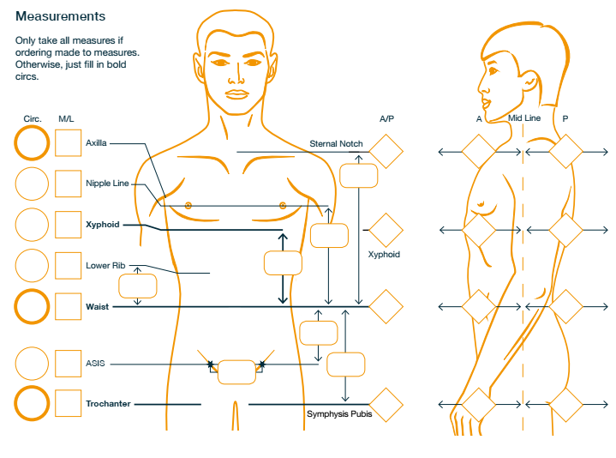

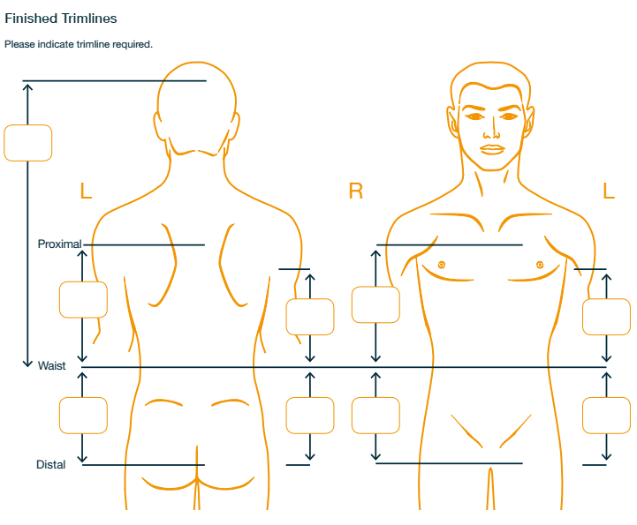

Other Specification:

____________________________________________________________________________________________________________________________________________________________________________________________________________________________________________________________________________________________________________